1. Match the following (many-many mapping)

Two sample links for your reference. Match others. (Each correct match – 2 mark. Each Incorrect match negative 2 mark)

|  |  |
| --- | --- |
| C#  Microsoft Windows  MS SQL  C  Oracle  Android OS  Java  Selenium  Eclipse  Symbian  Hadoop  Linux  DB2  Chrome OS  MongoDB  Spark  Intellij  Mac OS X 10.0 Yosemite  Flex  Sybase  HP QuickTestProfessional  HTML  LoadRunner | Programming language  Operating system  Database  BigData Technology  FrontEnd Technology  Development IDE  Testing Tool  Mobile operating system |

1. What all gets printed when the following program is compiled and run. Select the one correct answer. (4 marks)

public class test {

public static void main(String args[]) {

int i=0, j=2;

do {

i=++i;

j--;

} while(j>0);

System.out.println(i);

}

}

1. 0
2. 1
3. 2
4. The program does not compile because of statement "i=++i;"
5. Which of the following is a Java keyword? Select the four correct answers (Each correct choice – 2 mark. Each Incorrect choice negative 2 mark)
6. extern
7. synchronized
8. volatile
9. friend
10. friendly
11. transient
12. this
13. then
14. For below customer table .Answer queries

|  |  |  |  |
| --- | --- | --- | --- |
| customer_id | customer_name | street_city | zip_code |
| 1 | Salman Khan | Tower,Karimnagar | 505001 |
| 2 | Madhusudhan | HBC, Karimnagar | 505001 |
| 3 | Raheel | RamNagar,Karimnagar | 505001 |
| 4 | Nikhil | Vemulawada, VemulaVada | 500000 |
| 5 | Harish | GaneshNagar,Karimnagar | 505001 |

1. Select customerId from customer_table where customer_id >= 3. Select all possible ids (3 correct possible values). (Each correct choice – 1 mark. Each Incorrect choice negative 1 mark)
   1. 0
   2. 1
   3. 2
   4. 3
   5. 4
   6. 5
   7. 6
2. Select customer_id from customer_table where zip_code=505000

Ans:____________________

1. Select max(customer_id) from customer_table where zip_code=505001

Ans:_____________________

1. Select count(*) from customer_table where customer_id between 1 and 4

Ans: ____________________

Implement Bubble sort

Time limit-15-20 minutes. You can either implement the program in Java or C.

Code templates provided.

|  |
| --- |
| **JAVA**  import java.util.Scanner;    class BubbleSort {  public static void main(String []args) {  int n, c, d, swap;  Scanner in = new Scanner(System.in);    System.out.println("Input number of integers to sort");  n = in.nextInt();    int array[] = new int[n];    System.out.println("Enter " + n + " integers");    for (c = 0; c < n; c++)  array[c] = in.nextInt();  **//write code here**    System.out.println("Sorted list of numbers");    for (c = 0; c < n; c++)  System.out.println(array[c]);  } |

Sample Input/Output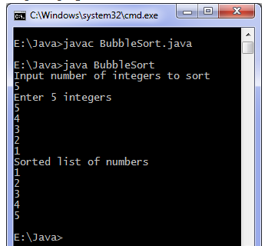

|  |
| --- |
| **C language**  #include <stdio.h>    int main()  {  int array[100], n, c, d, swap;    printf("Enter number of elements\n");  scanf("%d", &n);    printf("Enter %d integers\n", n);    for (c = 0; c < n; c++)  scanf("%d", &array[c]);  **//write code here**    printf("Sorted list in ascending order:\n");    for ( c = 0 ; c < n ; c++ )  printf("%d\n", array[c]);    return 0;  } |

Sample Input/Output

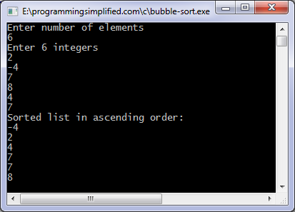

Write a program to test whether a palindrome string can be generated from a given string using all characters from the string. (Time limit : 45 minutes. You may not be able to finish the program in time, we are looking for the approach/algorithm)

|  |
| --- |
| What is palindrome?  Is a word, phrase, number, or other sequence of characters which reads the same backward or forward.  Example:  Mom  kayak |

Sample program Input/Output

Mmo True

Yakak True

Travel False

**Useful tips for interview/career guidance (Disclaimer: Based on my experience – not from a certified source)**

1. Make sure you proof read your resume multiple times, and have it reviewed by couple of HR professionals/recruiters and couple of experienced programmers

2. Write a synopsis of your opening statement in a interview(Tell me about yourself). Read it out to friends or infront of a mirror several hundred times (literally).

3. Prepare answers for run of the mill questions

a. What are your strengths and weakness?

b. Explain a scenario/situation that demonstrates your leadership/people skills

4. Below are few online websites i find useful

a. <http://www.careercup.com/>

b. monster.com indeed.com durgajobs.com ( job search sites, helpful in preparing resume/ picking up which technology to master)

c. <http://www.allapplabs.com/>

5. Books i find useful for Java

a. Effective Java (2nd Edition): Joshua Bloch: (Once you have atleast a year experience in Java)

Bubble sort - java

for (c = 0; c < ( n - 1 ); c++) {

for (d = 0; d < n - c - 1; d++) {

if (array[d] > array[d+1]) /* For descending order use < */

{

swap = array[d];

array[d] = array[d+1];

array[d+1] = swap;

}

}

}

Bubble sort – C

for (c = 0 ; c < ( n - 1 ); c++)

{

for (d = 0 ; d < n - c - 1; d++)

{

if (array[d] > array[d+1]) /* For decreasing order use < */

{

swap = array[d];

array[d] = array[d+1];

array[d+1] = swap;

}

}

}